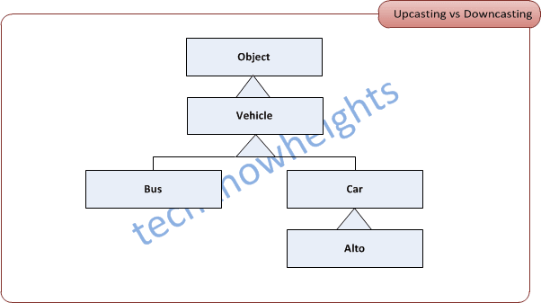

**Vehicle v1 = new Car(); //Right.upcasting or implicit casting  
  
Vehicle v2 = new Vehicle();**

**Car c0 = v1; //Wrong. compile time error "Type Mismatch".   
//Explicit or down casting is required   
  
Car c1 = (Car)v1; // Right. down casting or explicit casting.   
  
// v1 has knowledge of Car due to line1  
  
Car c2 = (Car)v2; //Wrong. Runtime exception ClassCastException   
//v2 has no knowledge of Car.   
  
Bus b1 = new Alto(); //Wrong. compile time error "Type Mismatch"  
  
Car c3 = new Alto(); //Right.upcasting or implicit casting   
  
Car c4 = (Alto)v1; //Wrong. Runtime exception ClassCastException   
  
Object o = v1; //v1 can only be upcast to its parent or   
  
Car c5 = (Car)v1; //v1 can be down cast to Car due to line 1.**